Coming Soon from the Author
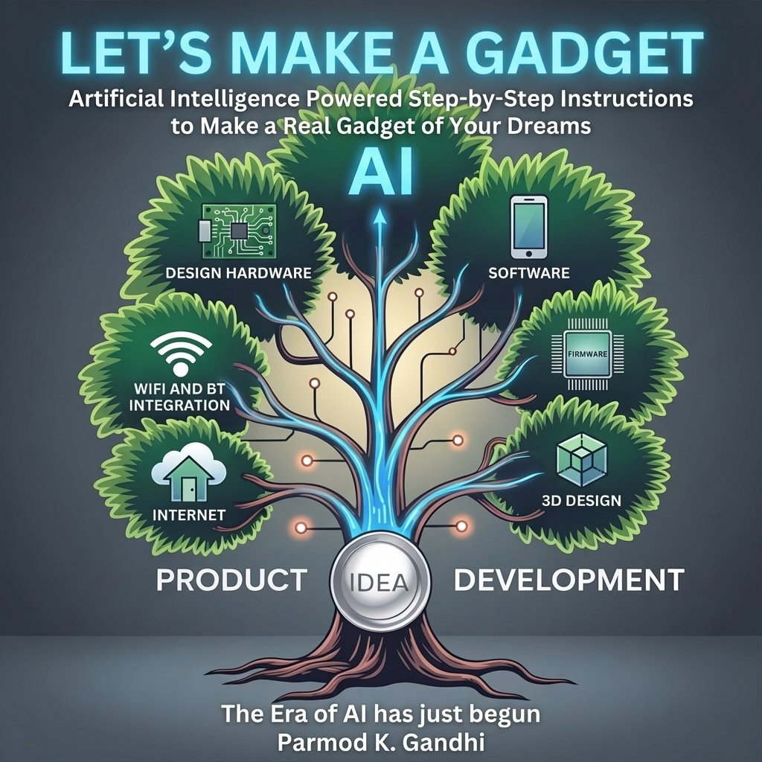 | Let’s Make a Gadget  Artificial Intelligence Powered Step-by-Step Instructions to Make a Real Gadget of Your Dreams  Have a product idea but no idea where to start? This book walks you through every stage of building a real connected IoT device — from the first sketch on paper to a finished product you can hold in your hand.  You will design the circuit board, write the firmware, build the mobile app, deploy the cloud server, design the 3D-printed enclosure, and launch it on Kickstarter. Every step. Nothing left out.  AI is your development partner throughout — not to replace your thinking, but to compress the learning curve and let one person do what used to take a team.  If you have ever wanted to build a real gadget, this is the book that shows you exactly how.
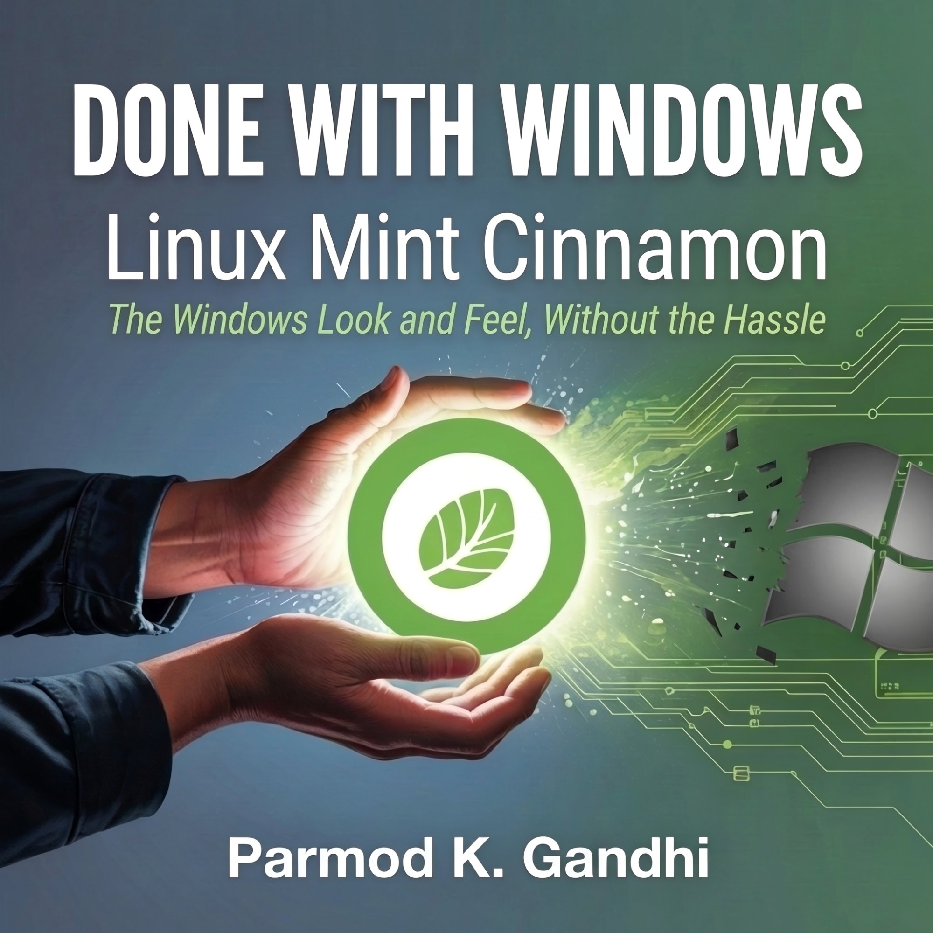 | Done with Windows  Linux Mint Cinnamon — The Windows Look and Feel, Without the Hassle  Tired of Windows updates, slowdowns, and the constant feeling that your computer is working against you? You are not alone — and there is a better way.  Linux Mint Cinnamon gives you a familiar desktop that looks and feels like Windows, runs faster on older hardware, costs nothing, and puts you back in control. No command line required.  This book guides you through every step: downloading Linux Mint, installing it safely alongside Windows or replacing it entirely, setting up your printers and applications, and making yourself at home in your new system.  Thousands of people have made the switch. This book makes sure yours goes smoothly.

